1. Agenda:
   1. Discuss on theory about Cloud Native Apps.
2. You will hear about buzz words “**Cloud Native Apps**” when attending interviews or discussing on microservices.
3. Different people would give different definitions of cloud native app.
4. Someone may say that cloud native app is all about changing the way we think about constructing a business app.
5. Other one: Cloud native systems are designed to embrace rapid change, large scale and resilience.
6. As per my definition: Cloud native app is a collection of small, independent and loosely coupled services.  
   Like microservices, they are designed to deliver well recognized business values like ability to rapidly incorporate user feedback for continuous improvement, it will bring speed and agility to your delivery.  
   Its main goal is to deliver the future that users want at the pace of business needs.
7. There is difference b/w cloud native app and microservice.
8. 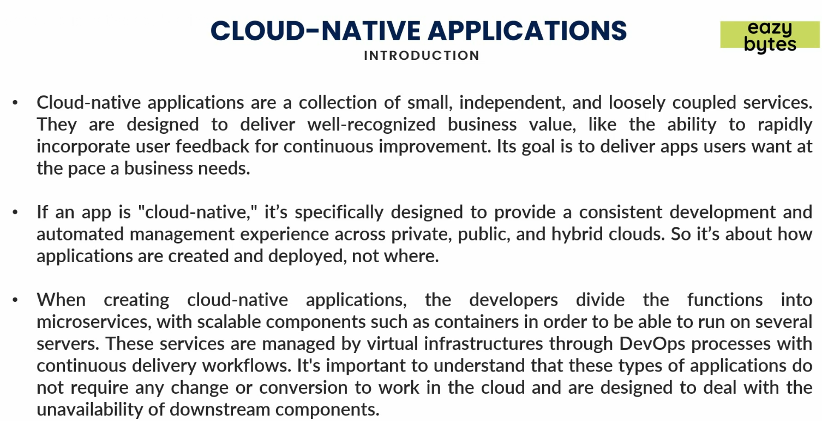
9. There are 4 components if you want to certify an app as Cloud Native App.
10. 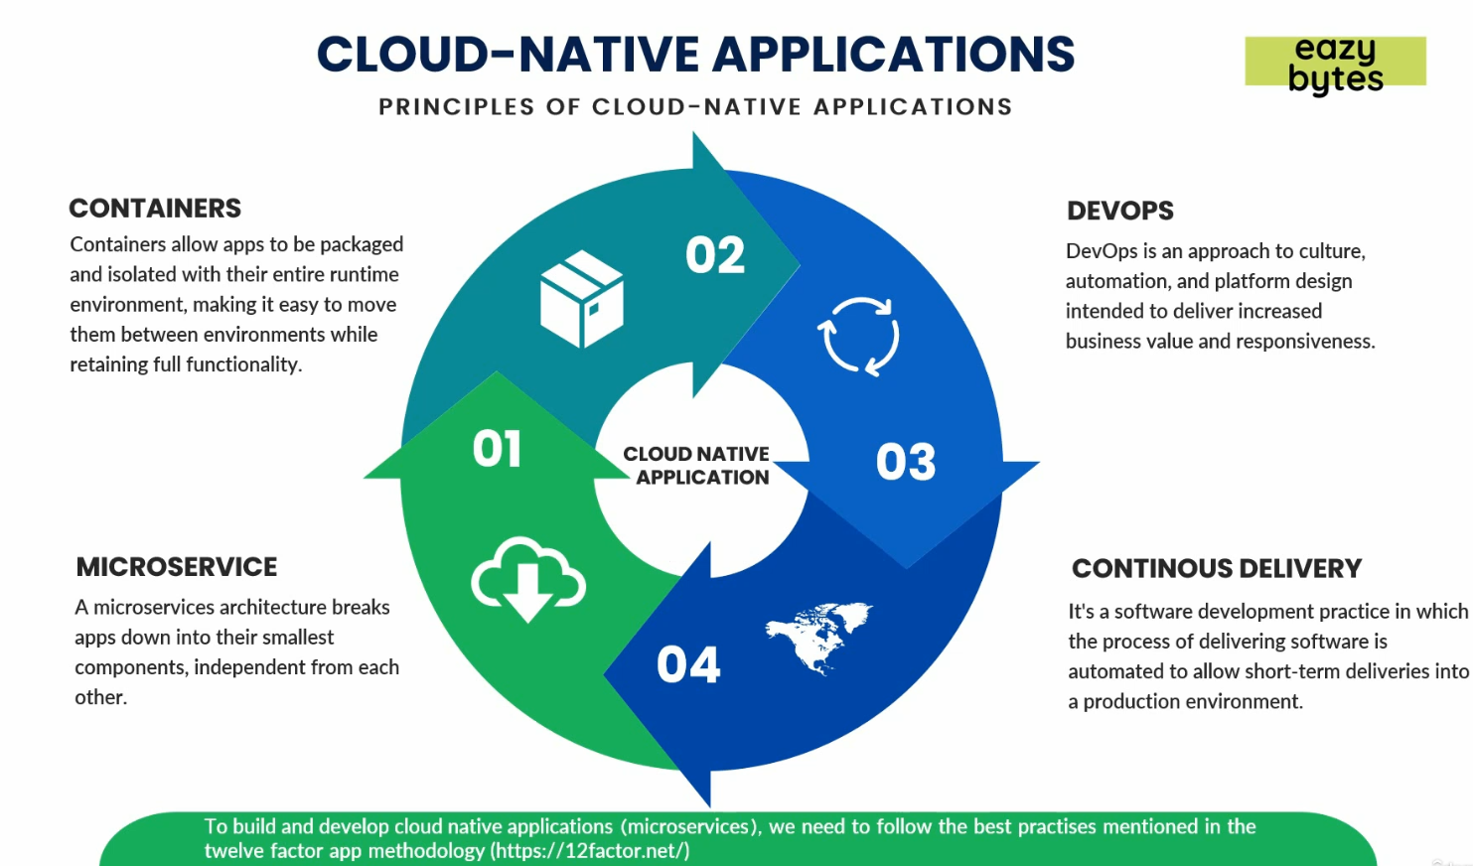  
    **NOTE**: Microservice is one component of Cloud Native App.